Зиганшиной Эльвиры 912

Урок 2 - Создание скрипта базы данных

Получившаяся диаграмма:

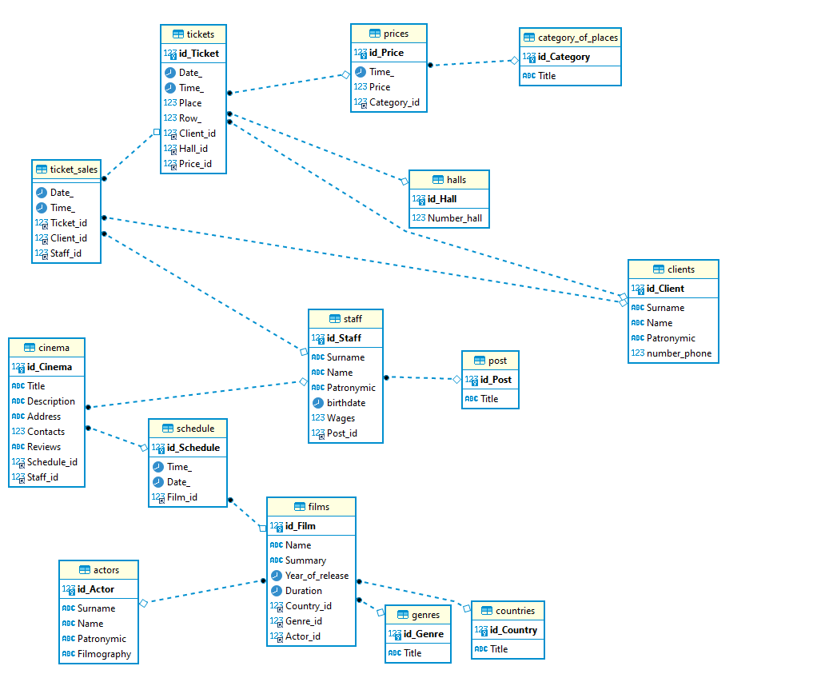

**drop** **database** **if** **exists** `Cinema`;

**create** **database** `Cinema`;

**use** `Cinema`;

**show** tables;

**create** **table** Clients(

id_Client **INT** **primary** **key** **auto_increment**,

Surname **VARCHAR**(50) **not** **null**,

Name **VARCHAR**(50) **not** **null**,

Patronymic **VARCHAR**(50) **not** **null**,

number_phone **INT**

);

**create** **table** Post(

id_Post **INT** **primary** **key** **auto_increment**,

Title **VARCHAR**(255) **not** **null**

);

**create** **table** Halls(

id_Hall **INT** **primary** **key** **auto_increment**,

Number_hall **INT** **not** **null**

);

**create** **table** Category_of_places(

id_Category **INT** **primary** **key** **auto_increment**,

Title **VARCHAR**(255) **not** **null**

);

**create** **table** Actors(

id_Actor **INT** **primary** **key** **auto_increment**,

Surname **VARCHAR**(50) **not** **null**,

Name **VARCHAR**(50) **not** **null**,

Patronymic **VARCHAR**(50) **not** **null**,

Filmography **VARCHAR**(255)

);

**create** **table** Genres(

id_Genre **INT** **primary** **key** **auto_increment**,

Title **VARCHAR**(255) **not** **null**

);

**create** **table** Countries(

id_Country **INT** **primary** **key** **auto_increment**,

Title **VARCHAR**(255) **not** **null**

);

**create** **table** Staff(

id_Staff **INT** **primary** **key** **auto_increment**,

Surname **VARCHAR**(50) **not** **null**,

Name **VARCHAR**(50) **not** **null**,

Patronymic **VARCHAR**(50) **not** **null**,

birthdate **DATE**,

Wages **FLOAT**,

Post_id **INT**,

**foreign** **key** (Post_id) **references** Post(id_Post)

);

**create** **table** Prices(

id_Price **INT** **primary** **key** **auto_increment**,

Time_ **TIME**,

Price **FLOAT** **not** **null**,

Category_id **INT**,

**foreign** **key** (Category_id) **references** Category_of_places(id_Category)

);

**create** **table** Tickets(

id_Ticket **INT** **primary** **key** **auto_increment**,

Date_ **DATE** **not** **null**,

Time_ **TIME** **not** **null**,

Place **INT** **not** **null**,

Row_ **INT** **not** **null**,

Client_id **INT** **not** **null**,

Hall_id **INT** **not** **null**,

Price_id **INT** **not** **null**,

foreign **key** (Client_id) **references** Clients(id_Client),

**foreign** **key** (Hall_id) **references** Halls(id_Hall),

**foreign** **key** (Price_id) **references** Prices(id_Price)

);

**create** **table** Ticket_sales(

Date_ **DATE**,

Time_ **TIME**,

Ticket_id **INT** **not** **null**,

Client_id **INT** **not** **null**,

Staff_id **INT** **not** **null**,

**foreign** **key** (Ticket_id) **references** Tickets(id_Ticket),

**foreign** **key** (Client_id) **references** Clients(id_Client),

**foreign** **key** (Staff_id) **references** Staff(id_Staff)

);

**create** **table** Films(

id_Film **INT** **primary** **key** **auto_increment**,

Name **VARCHAR**(255) **not** **null**,

Summary **VARCHAR**(255),

Year_of_release **DATE**,

Duration **TIME**,

Country_id **INT**,

Genre_id **INT**,

Actor_id **INT**,

**foreign** **key** (Country_id) **references** Countries(id_Country),

**foreign** **key** (Genre_id) **references** Genres(id_Genre),

**foreign** **key** (Actor_id) **references** Actors(id_Actor)

);

**create** **table** Schedule(

id_Schedule **INT** **primary** **key** **auto_increment**,

Time_ **TIME** **not** **null**,

Date_ **DATE** **not** **null**,

Film_id **INT**,

**foreign** **key** (Film_id) **references** Films(id_Film)

);

**create** **table** Cinema(

id_Cinema **INT** **primary** **key** **auto_increment**,

Title **VARCHAR**(255) **not** **null**,

Description **VARCHAR**(255),

Address **VARCHAR**(255) **not** **null**,

Contacts **INT** **not** **null**,

Reviews **VARCHAR**(255),

Schedule_id **INT**,

Staff_id **INT**,

**foreign** **key** (Schedule_id) **references** Schedule(id_Schedule),

**foreign** **key** (Staff_id) **references** Staff(id_Staff)

);